

Process Definition Document

Contz Alexandru-Ioan | ULBS Inginerie | Calculatoare (ZI) | An I licență
Părău Leonard-Adrian | ULBS Inginerie | Calculatoare (ZI) | An I licență
Deac Ştefan-Adrian | ULBS Inginerie | Calculatoare (ZI) | An I licență
<client name>
Contoso Financial Services
<process name>
File Sorter: Automatic workflow maintainer

Note
Before any business process can be automated, it needs to be documented carefully.
The Process Definition Document describes how a specific set of operations is currently done in the organization, to collect all the information required in a clear, explicit, and shared way. What are the systems involved? Which steps are now performed manually to reach the end goal? What are the possible exceptions? How often is this process executed? What are the rules in place? This document must provide answers to these questions.
This information, once validated by all parties involved, will be used as the basis for the next phases in the automation of the process.
This document needs to be kept up to date with any possible changes in the involved systems and procedures for the whole lifecycle of the automation process, and all changes need to be signed off.

Document Version History
(Processes rarely stay the same for very long, and if the process changes or there is some new information, you should create a new version of this document, and archive the previous one. Remember to keep this section up to date!)

Version | Author | Date
1.0 | Contz Alexandru | 30.05.2025
1.1 | Deac Stefan | 31.05.2025

Signed off by
(When the process has been accurately described and all is good to go, make sure that the document is signed off by the relevant people, e.g. the process owner. By signing off this document, you ensure that they have carefully checked it through, and they agree to the content. This is important, so that later when there are changes in the process (it always happens, that's life!), everyone has a clear understanding of what the scope was originally.)
Name | Function | Responsibility
Contz Alexandru - Ioan | Lead RPA-Developer, App designer | Creates, ensures and maintains the RPA automatization
Deac Ștefan - Adrian | Lead Coordinator, RPA Developer, External Management, Business Analyst | Coordinates team and project. Sets the trajectory of the project
Părău Leonard - Adrian | RPA Tester, Process error manager, App analysis, Reviews and helps improve the project, | Tests, reports, analyzes and finds bugs or errors.  Helps widen product usability and integration

Contributors
(Who are the people that have been involved in providing the information needed for this document? Who is responsible for it?)

Name | Function | Responsibility
Michael Chen | Senior RPA Developer | Process design & automation
Lisa Wang | Business Analyst | Requirements gathering
Robert Kim | Office Administrator | Provided manual process details

Current process analysis
(This section is where you will use your great analyst skills to describe how the client is handling the process now, before you move in and optimize and automate it like a pro. What are the steps that someone inside the company has to do each time to make this process work? What software do they have to use? Where do they get the information they need? What happens if something goes wrong? All these questions need to be answered in this section.)

High-level description
(Here you should give an overview of the process. What is this process for? How often do they run it? When do they run it? Who runs it? What are the steps?
This should be crystal clear and not too long to read.)
The process is used to.... automate file movement and maintain a clean workflow with ease.
The <employee> James Peterson <each Tuesday at 10 am> :
- <Logs into the system>...
- Runs the file sort automatization
- Fills in the configuration wizard.
- Enjoys a clean file system and workflow boosting productivity and lowering frustration.

Systems involved
(Processes that are a good fit to be automated by RPA often span across different systems. One could be a web application, another a legacy system, or even just a spreadsheet. List here the systems involved, don’t forget to explain what they are used for and also if the user needs to have special authorization roles or rights, because the robot will probably need to have them as well!)
System | Used for | User role needed
Windows File System | Reading and writing to files.  Source and destination handling. | Read/Write Permissions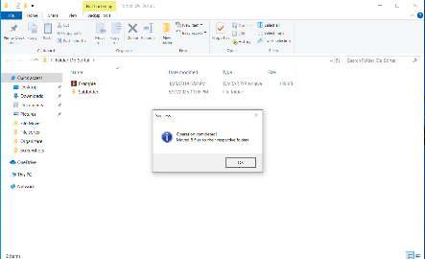
TAP Studio C# scripting | Variable parsing, error catching, advanced functions | Basic user roles.

Process flow
(A good flowchart is worth a thousand words! You can brush up on the (few) rules needed to make a good flowchart here, and then get charting!
Here is a description of the process in the form of a flow chart. Here’s what a very simple flowchart could look like:)
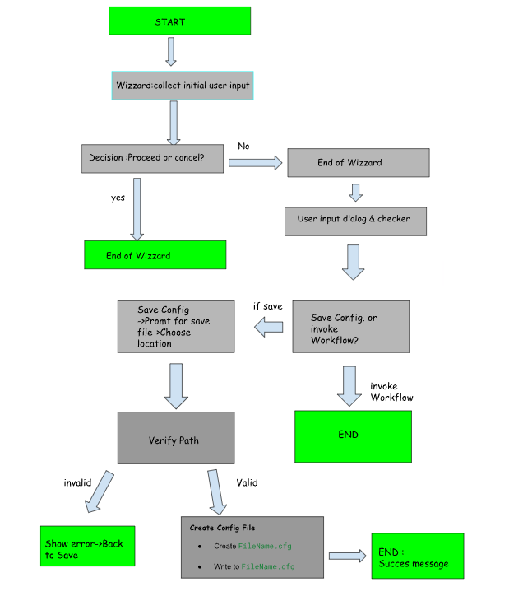

Detailed steps
(Now it’s time to get into the details! Break down the process into all its steps, and for each one provide all the information needed. Try to imagine that you are explaining this to someone that knows nothing about the process. They should be able to complete the process on their own after they have read your clear instructions!)

User begins automation wizard
(A good name for a step for example is in the format “<operator> <action> <object of the action>”. For example: “The employee clicks the button "Add to Cart" next to the product. The product is added to the shopping cart". This is not a hard rule though.)
The user will be prompted to continue or to cancel the automation wizard if they ran it on accident. This ensures that the wizard is not ran on accident for example the user launching the wizard instead of the File Sorting automation when they already have a configuration file and want to run it.
(In the description of each step, you are free to add anything that you think will help explain it better. Screenshots of the user interface, the schema of the data involved, etc.)
<Description of the step>

User is prompted to select one or more folders to sort
The user is prompted to select one or more folder paths from which the program will sort. The paths will be verified based on if they are empty, inaccessible, invalid or already included previously by the user. Then they will be added in a list of type string.
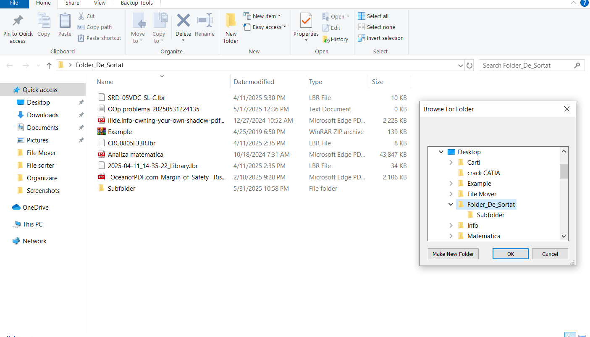
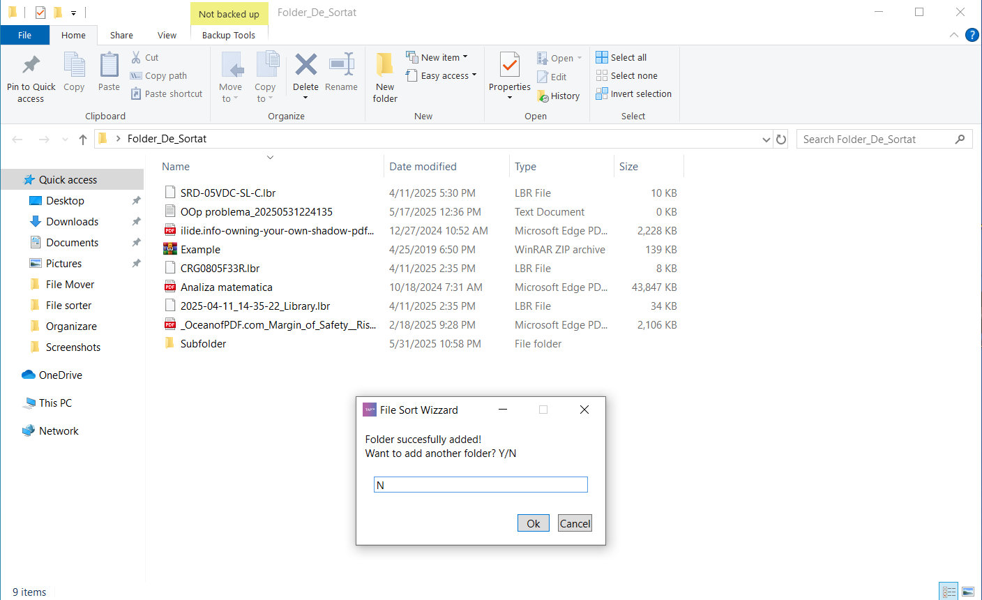

User is prompted to select the destination folder
The user is prompted to select one folder path where the program will place sorted items. The path will be verified and the added to a string variable.

User is prompted to select other features
The user is prompted to select from 2 additional options. The first one is to include Sub-Folders (Sub-Paths) to be sorted from the selected folders. The second one makes it so that the files are also saved in separate folders based off file type in the given destination folder.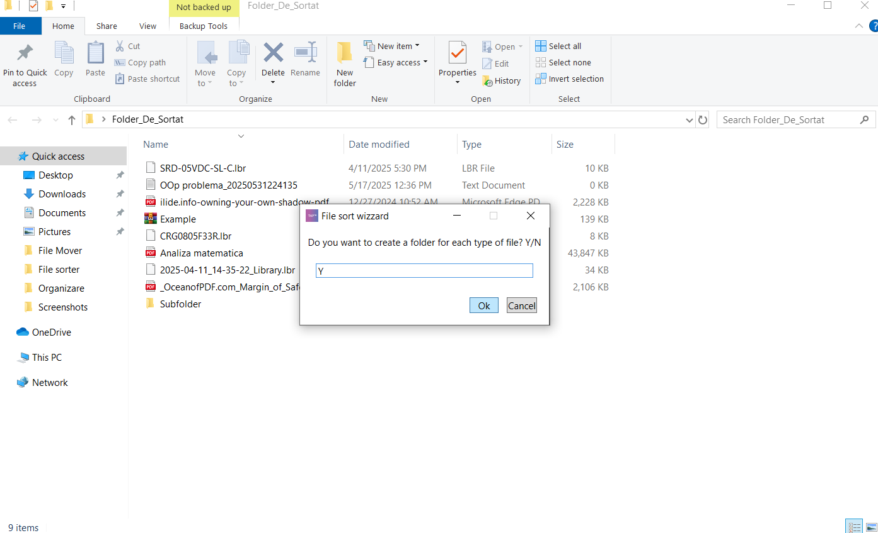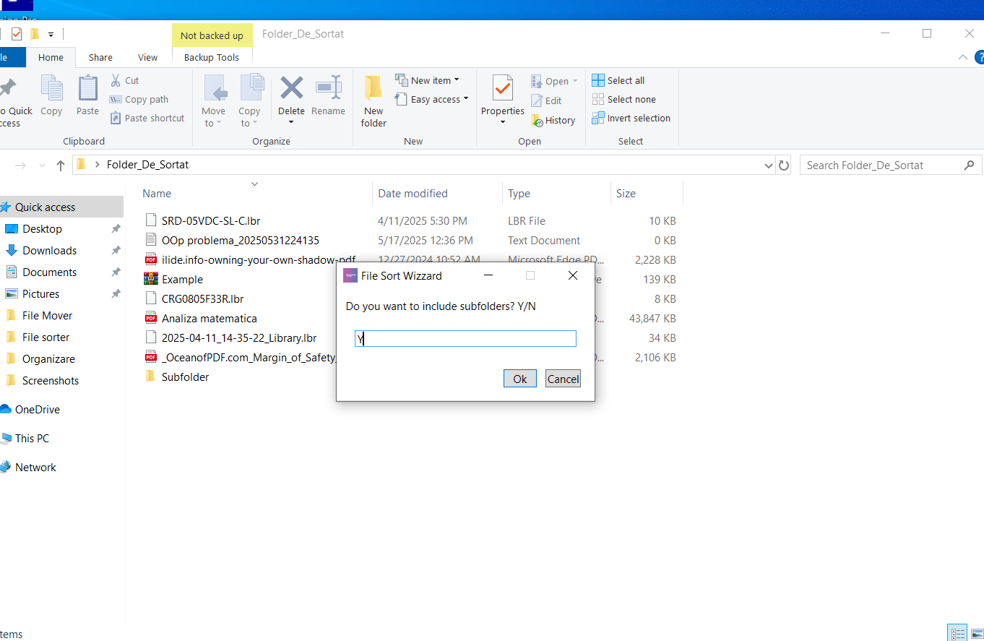

User is prompted to modify extensions (supported file types)
The user is prompted to a window that lists default file types supported by the program. The user can continue with default extensions or he can modify them by using arguments such as +. extension -. extension in the user input prompt. If the given argument/input box is blank the default extensions are loaded; if the input box contains with a + or – the input box is sent as a string to a function that verifies and corrects possible mistakes. For example, you can use +.rtf and +rtf, they are the same thing.
After the input is received and processed a message box shows showing the modified extension list and what was added and removed, as a confirmation dialogue, the user being prompted if they want to redo this step or if they want to proceed with the setup.
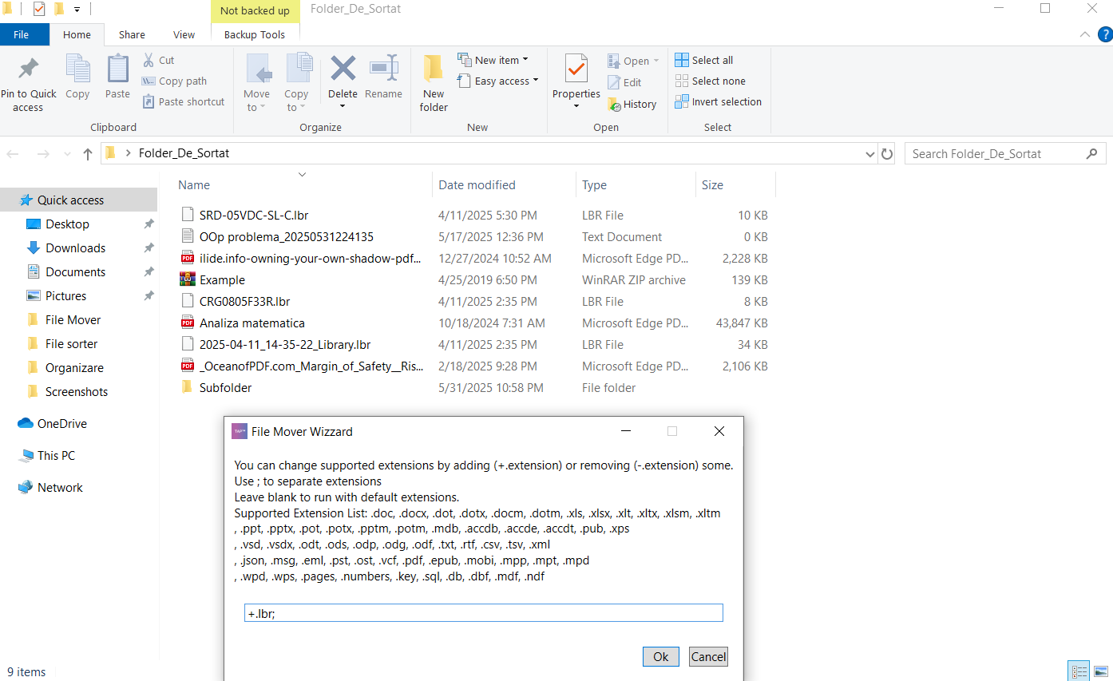
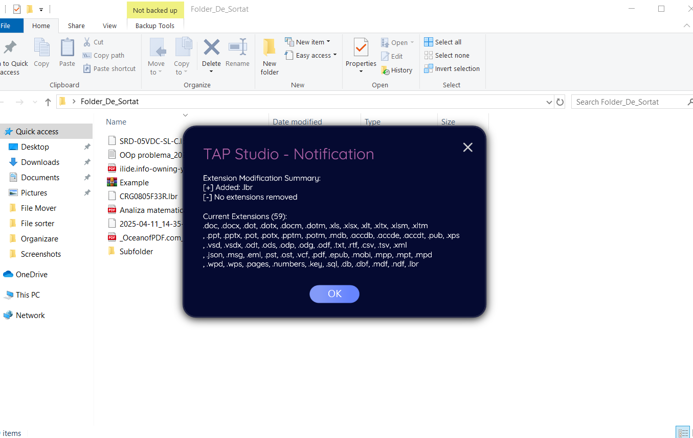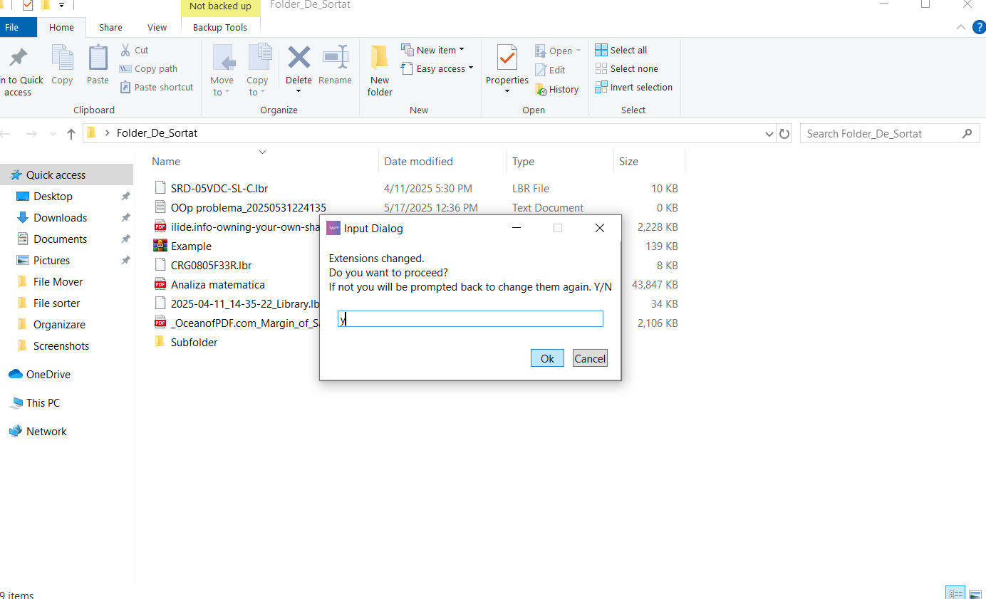

User is prompted to save changes or discard
The title says it all. If user continues, step 7 is next.
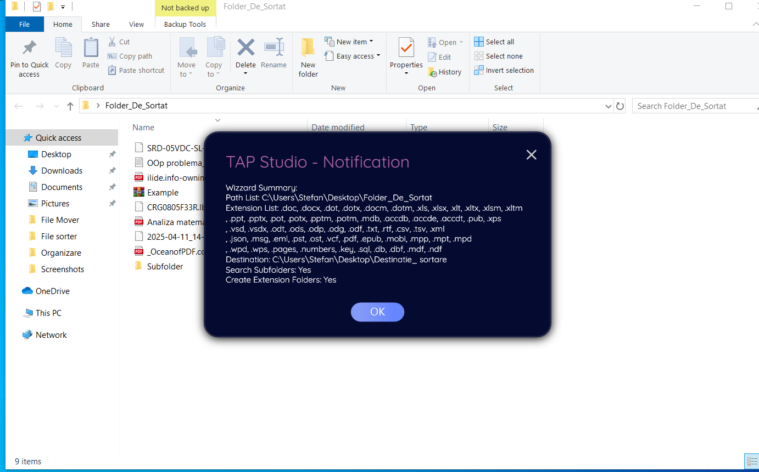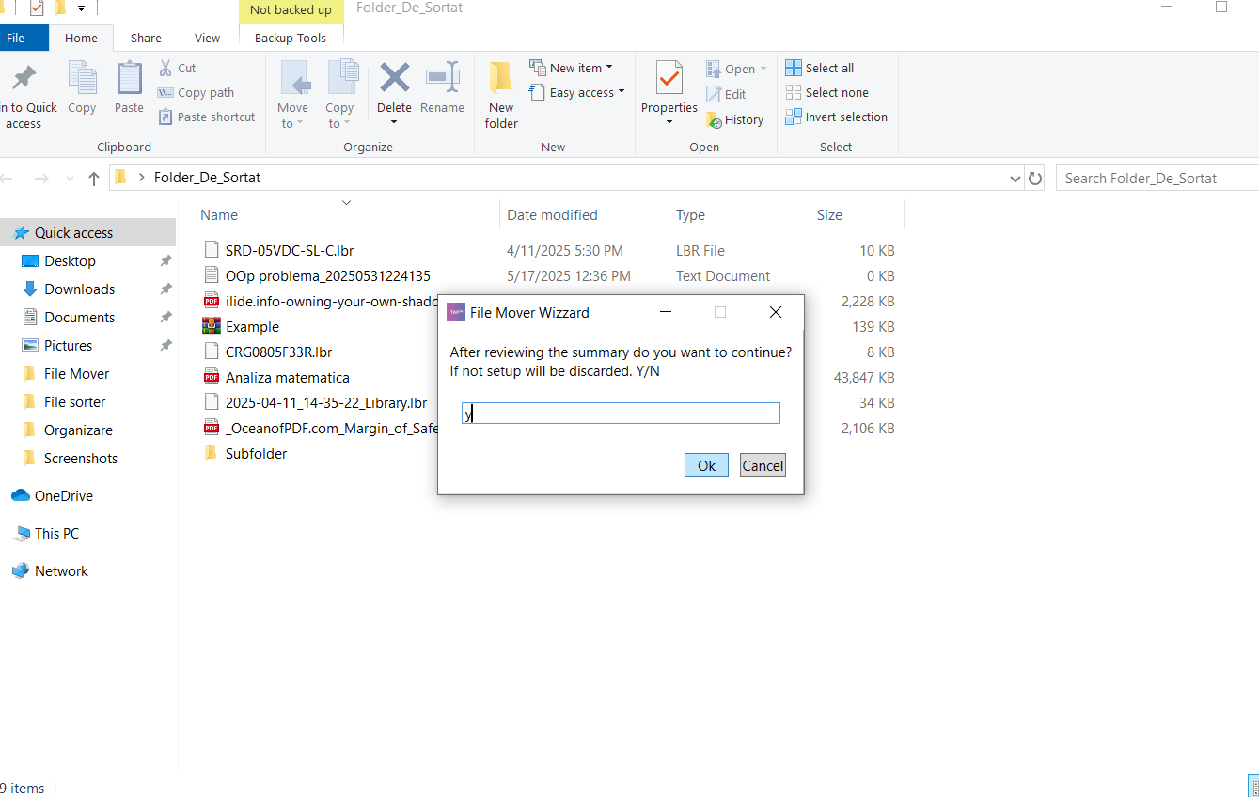

User is prompted to select if they want to run the configuration now or store it in a file for later
This is the final step of the configuration wizard, the user can select a folder/path to store the configuration file or use the current configuration of the wizard now. The file contains a string that has variables needed for the File Sorter Automatization workflow. If the user uses the current wizard configuration, then the same variables will be sent trough as arguments in the next workflow (File Sorter automatization). 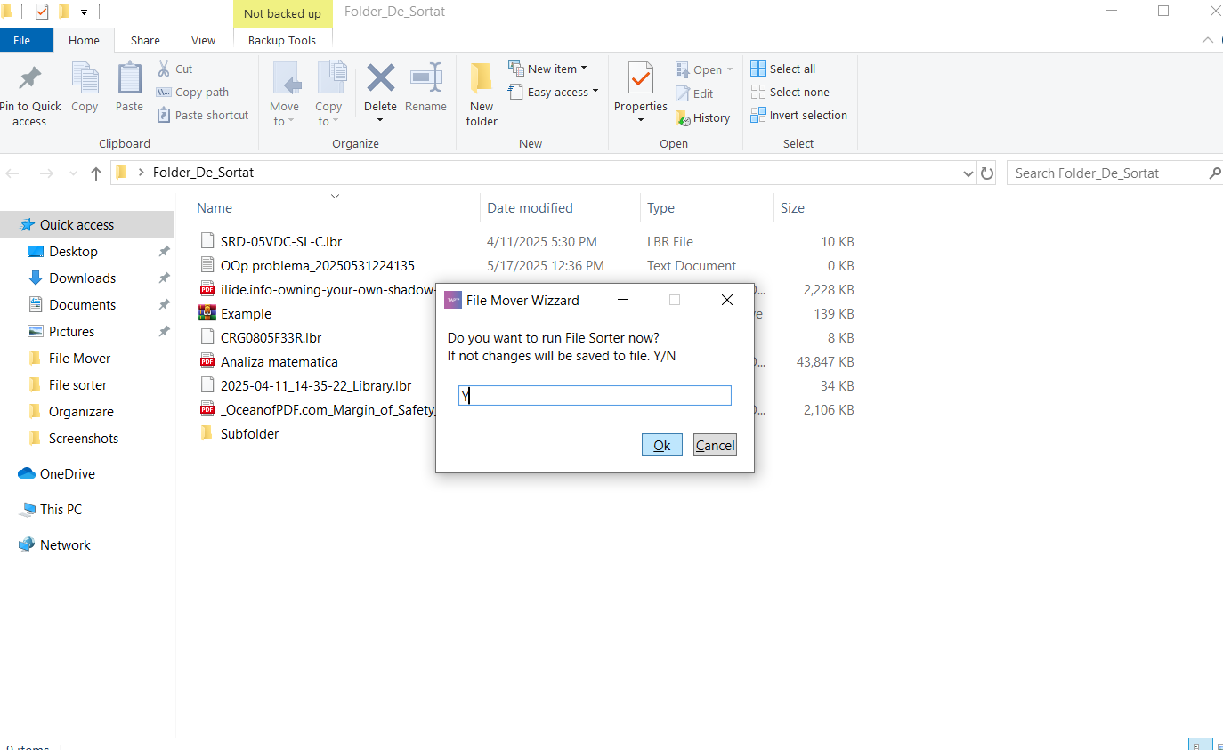

User will run the 2nd workflow
When this workflow runs it will prompt the user and automatically determine if the data is being sent form the wizard or if the user needs to specify the file location of a configuration file. The data is being transitioned from one workflow to the other seamlessly and all the correct checks and verifications regarding file paths are made.

User completes the setup
The user is prompted one last time if they want to apply the configuration and sort the specified files. After the user agrees the files will be sorted according to the configuration.
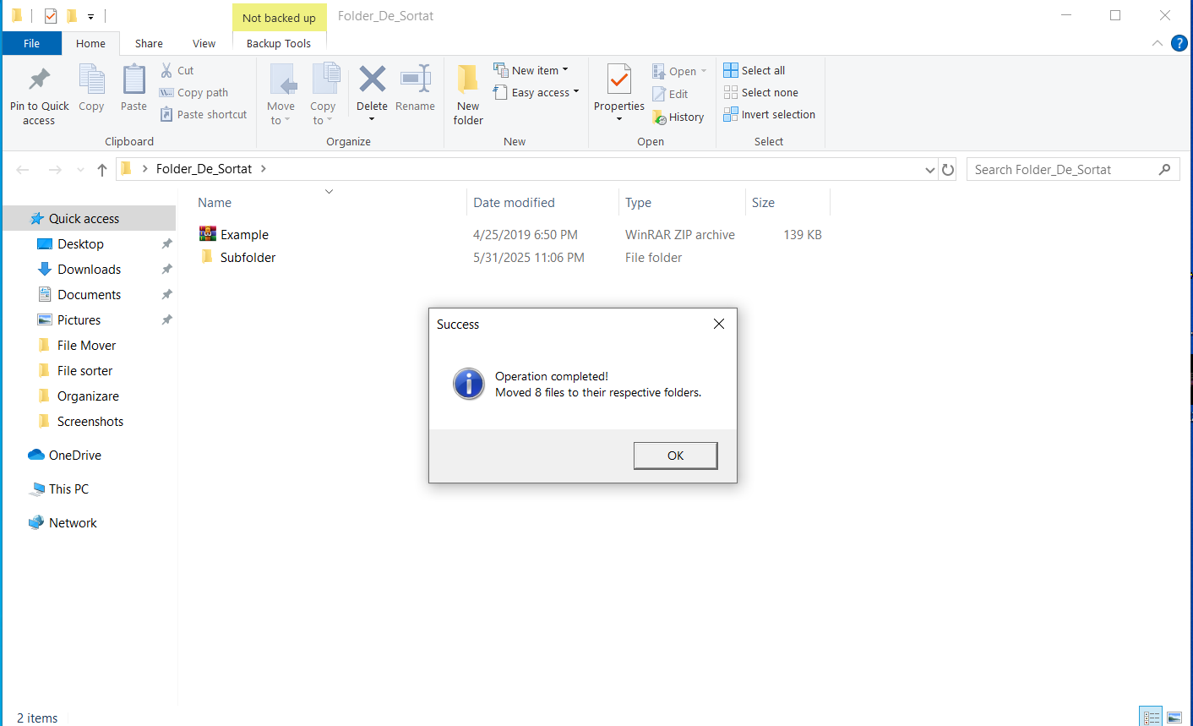
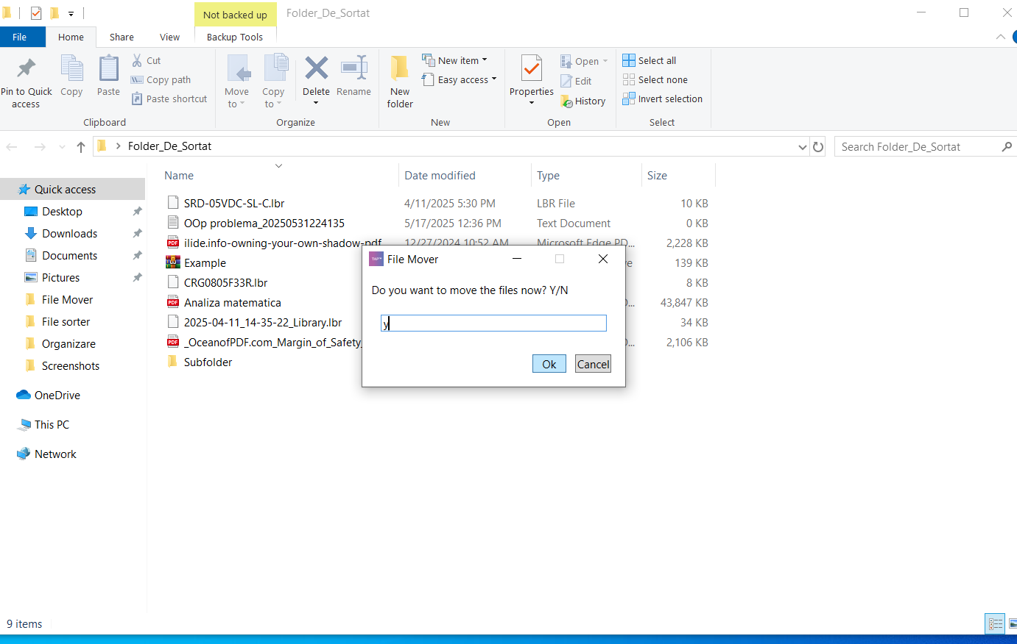

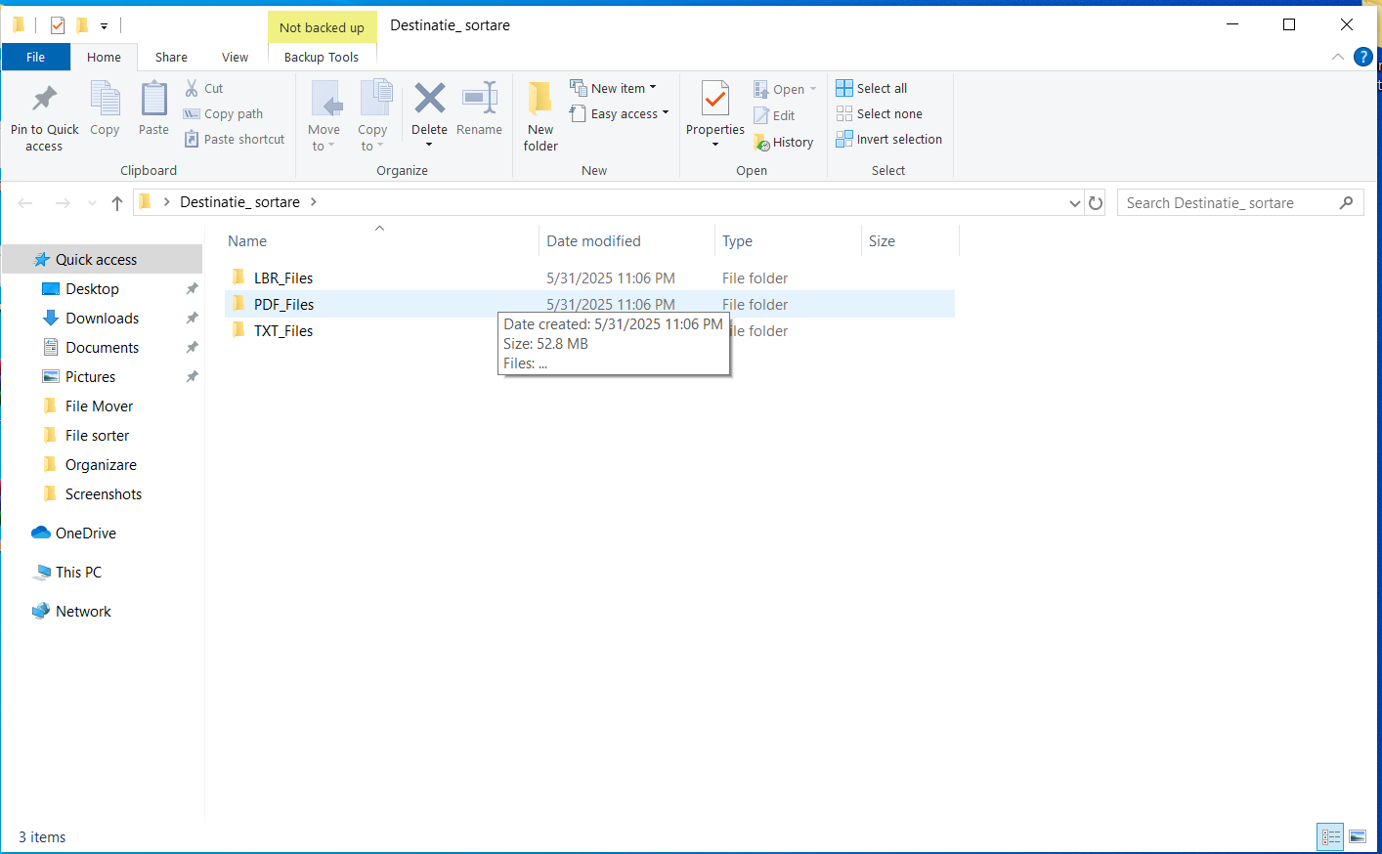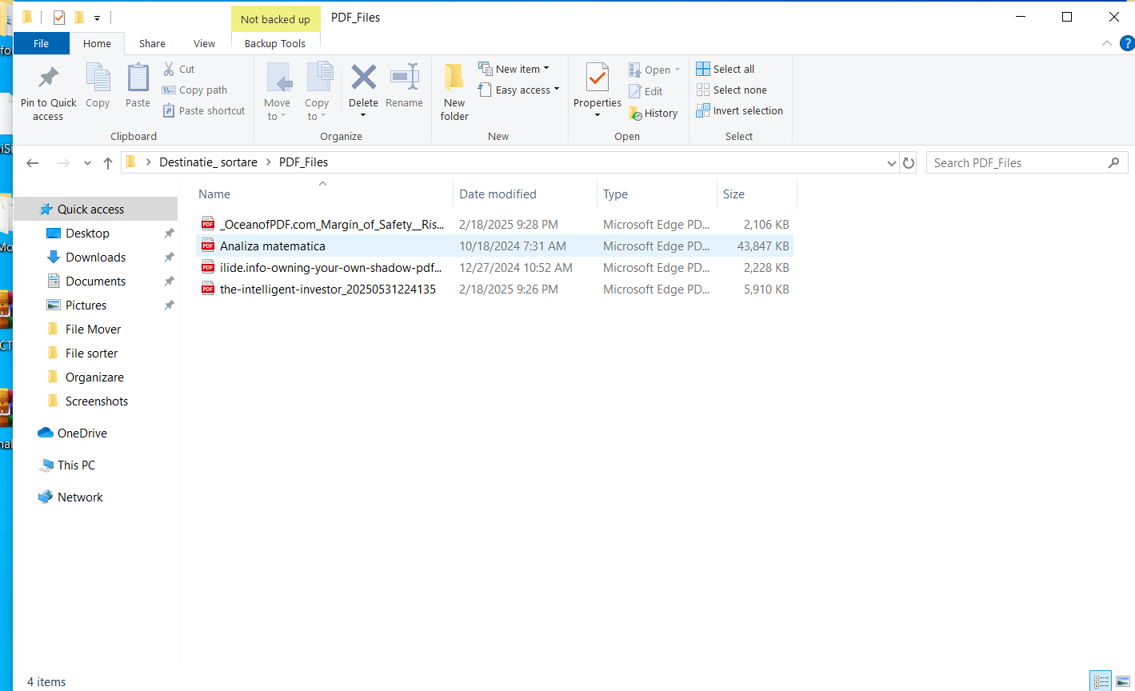

Possible exceptions
(This part is really really important: so far you have been describing an ideal case, where the operator has all the data they need, all systems work perfectly together and everybody is happy. But, there are times where the process does not run that smoothly for various reasons: we call these cases “Exceptions”. Exceptions are special cases and rules that can influence and even stop the smooth running of the process. )

Logic Exceptions
(Logic exceptions happen when something is wrong with the information that is being processed. For example, if an order has incomplete data, the operation has to stop. Or maybe the business has certain rules that it has decided on and the operator knows about: “do not sell more than 10 pieces a day for that product”. These need to be written down here carefully, because the robot will have to follow the same rules.)

<Logic exception1>
- Do not include unsupported files, if you do so edit the extensions array
- Do not shut down the machine while the setup is running: possible loss of data and/or progress
- Be sure to not select system directories
- Be sure to not select folders that are used in other projects/programs
<Description of logic exception1>
...

System Exceptions
(Software can have bugs, network connections can fail, passwords can no longer be valid: in all these cases we say that a system exception has happened. Write down all these possible cases, explaining what the operator sees, and also if there are ways to get around them.

<System exception1>
- Operating system needs to be Windows
- The Windows 10 version needs to be at least 1903 for TAP Studio to run properly
- Be careful when sandboxing TAP System services, program may lose functionality
- The system needs to have at least the minimum specs required to run TAP Studio
- Other system dependencies/registers need to be intact
<Description of system exception1>
System Exceptions in the Flowchart:

1.Invalid Path:
Where: "Verify Path"
What happens: If invalid, loops back to “Save to Config”
User sees: Likely an "Invalid path" message
Fix: Enter a valid path

2.Setup Canceled
Where: “Setup Canceled” box
What happens: Shows cancellation message, ends flow
User sees: “Setup was canceled”
Fix: Restart wizard

